1. BUG: cannot find the time conflict between lab/tutorial or lab/lec

array{engr213,comp248,comp232}

initial: there is a conflicts, comp232 lecture and comp232 lab are both 1745 to 2015 date j.

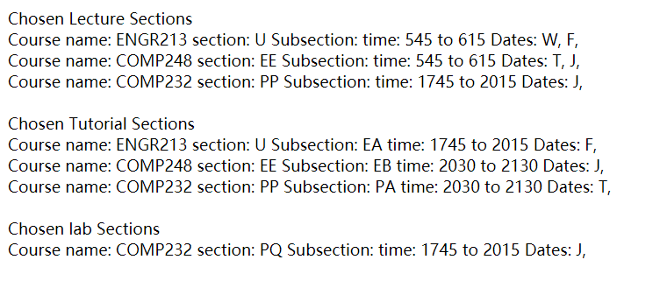

it should pick comp232_lab2

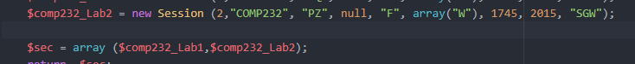

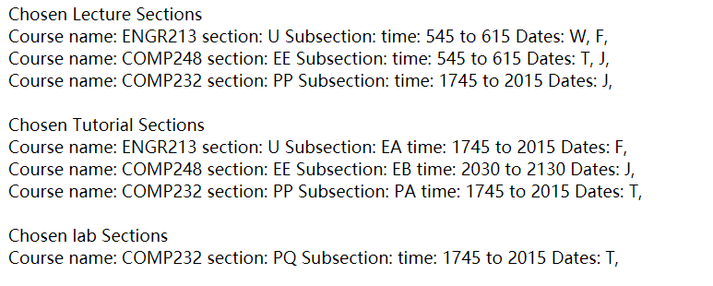

+++++++++++++++++++++++++++++++++++++++++++++++++++++++++++++++

second problem: cannot pick backup option if there is conflict

array{engr213,comp248,comp232} //initial has no conflict

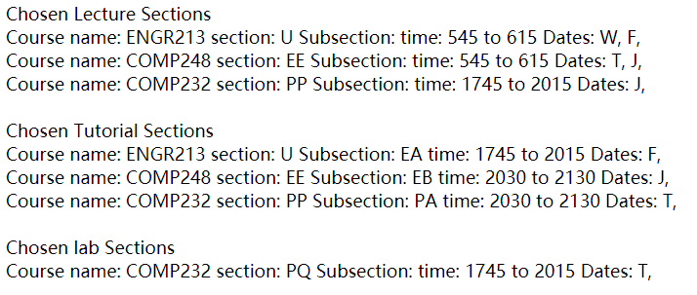

pick 2 of 3:

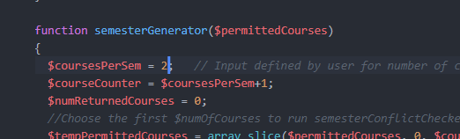

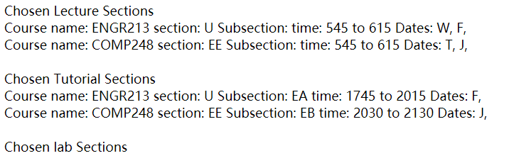

now set conflict between 213 and 248

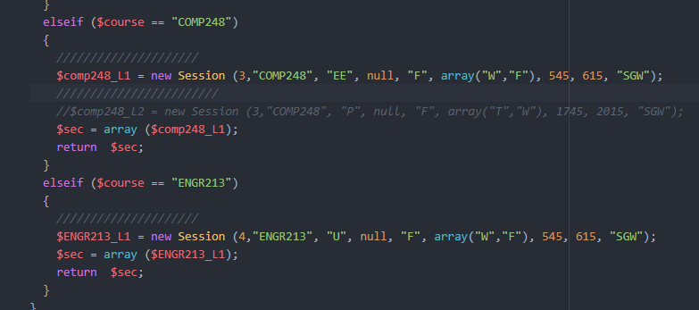

Both WF, 545-615

So we should pick COMP232 as backup option//{engr213,comp232}

